EX.NO: 7

SELECT with Various Clauses – GROUP BY, HAVING, ORDER BY
AIM
To retrieve records from the MobileSales table using GROUP BY, HAVING, and ORDER BY clauses.

PROCEDURE
- Select the required database using the USE command.
- Display the records from the MobileSales table.
- Group the records using the GROUP BY clause.
- Filter grouped records using the HAVING clause.
- Sort the records using the ORDER BY clause.
- Observe the output of each query.
- Verify that the GROUP BY, HAVING, and ORDER BY clauses retrieve the required records successfully.

COMMANDS
1. Select the Database
USE MobileDB;
2. Display All Records
SELECT * FROM MobileSales;
3. GROUP BY
SELECT ModelYear,
SUM(UnitsSaled) AS TotalUnitsSold
FROM MobileSales
GROUP BY ModelYear;

4. GROUP BY with HAVING
SELECT ModelYear,
SUM(UnitsSaled) AS TotalUnitsSold
FROM MobileSales
GROUP BY ModelYear
HAVING SUM(UnitsSaled) > 10000;
5. GROUP BY with ORDER BY
SELECT ModelYear,
AVG(Price) AS AveragePrice
FROM MobileSales
GROUP BY ModelYear
ORDER BY AveragePrice DESC;

6. ORDER BY
SELECT *
FROM MobileSales
ORDER BY CustomerReview DESC;
OUTPUTS
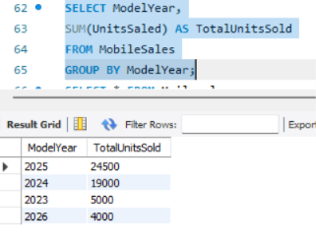

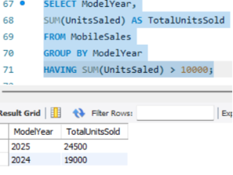

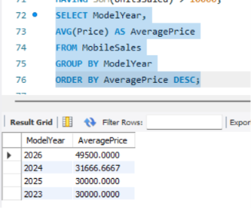

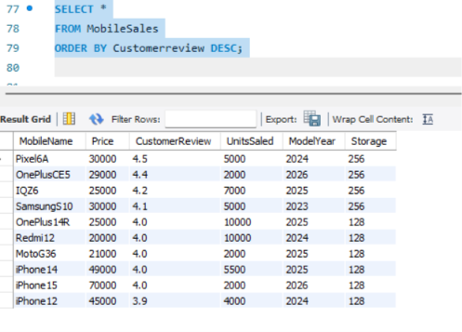

RESULT
Thus, the GROUP BY, HAVING, and ORDER BY clauses were successfully executed on the MobileSales table to group, filter, and sort the records.

